**ME-Project Report**

**about**

**Quad-rotors & Payload system dynamics and stability**

By: Ran , Oct 2017

# Abstract

This report is the summary of my research work as part of Master of Engineering in Autonomous Systems and Robotics ( [TASP](http://tasp.technion.ac.il/) ).

In this research, I am investigating the stability of payload carried by a 2 quadrotors ‘array’, under certain conditions. This case is in interest because of possible payload delivery mission required by companies such ‘Amazon’ and others, to deliver a relatively big-size and heavy payload – a mission that is not always possible for 1 quadrotor alone.

I’ll show the model equations of motion, analytical investigation and a numerical investigation results for comparison.

This report will show the system bifurcation structure , and highlight interesting parameters thresholds.

Table of Contents

Abstract 1

1. Introduction 3

2. Nomenclature 5

3. Problem formulation and system dynamics 6

model assumptions 6

Coordinate systems, and general coordinates 7

The Lagrangian of the system 8

non-conservative forces 9

Equations of Motion (dimensional) 9

Non-dimensional Equations of Motion 10

further analysis assumptions 11

4. Equilibrium analysis 11

Equilibrium points: 11

Linearizing about that equilibrium point 11

Reducing order of the system dynamics to 2DOF 12

5. Asymptotic analysis 13

Maneuvers 13

6. Numerical analysis 14

7. Discussion 14

Summary 15

Acknowledgements 15

References 16

Appendices 18

Appendix 1 –Limiting case dynamics – elastic pendulum 18

Linearization around the equilibrium point 19

Appendix A –Equations of Motion for 9D.O.F case 21

Appendix B –Linearization, and natural frequencies 22

Appendix C –system parameters vs. natural frequencies 25

Appendix D – reducing system’s DOF 27

# Introduction

There is a growing amount of interest in the controlled autonomous behavior of collectively operating unmanned aerial vehicles. An example is an array of autonomous quadrotors which are under consideration for a variety of missions including surveillance [Acevedo et al., 2012], heavy payload delivery [Bernard et al, 2011], and assembly of structures [Kumar and Michael, 2012]. While there is an abundance of documentation of multi-agent behavior of very large groups (or swarms) such as flocks of birds and schools of fish which can quickly adapt to a complex terrain [Shklarsh et al, 2011] or environmental conditions [Elor and Bruckstein, 2011; Agmon et al, 2011], and an uncertain and changing environment in nature [Young et al, 2013], there is limited research on small size arrays of autonomous elements that continue to maneuver collectively under severe environmental conditions.

Documented research on single quadrotor dynamics, stability and control consists of rigid-body dynamical systems models augmented by angular rotor dynamics [Leishman 2006]. Investigations include nonlinear control for take-off, hovering and landing [Kendoul et al, 2007] and to overcome path following uncertainties [Raffo et al, 2010] and disturbances [Schoellig et al., 2012]. Control of aggressive maneuvers such as flying through a narrow gap [Mellinger et al, 2012] have been implemented, and investigations include robustness analysis applied to wind gusts [Alexis et al, 2011; Escareno et al, 2013], and control of cable suspended payload has been proposed [Sreenath et al, 2013].

Recently, there is increasing interest in payload carried by more than 1 vehicle, investigating better controls and better flight structure to get better performance for flight stability and distance [J. Enciu 2017].

Motivated by simulation studies of decision making in animal groups in motion, the stability of multiagent particle dynamical systems models have been analyzed to reveal cohesive behavior [Liu and Passino, 2005] and separation of fast and slow time scales reflecting a local bifurcation structure indicative of a compromise by individual elements with conflicting preferences [Nabet et al., 2009]. Symmetrical and asymmetrical bifurcations have been shown in a swarm robotics test bed [Garnier et al, 2013] and a noise intensity threshold was shown to govern swarm transition from a misaligned state into an aligned state [Mier et al, 2012]. Furthermore, nonlinear multi-agent swarm models exhibit existence of periodic limit-cycles culminating with non-stationary chaotic solutions [Das et al, 2012], and stochastic bifurcations [Ebeling and Schimansky-Geier, 2008].

In the light of the current scientific background the behavior in severe environmental conditions is yet unresolved. Thus, this paper’s aim is to derive a consistent dynamical systems model for a 2-element ‘array’ of quadrotors which can withstand severe and unsteady aerodynamic disturbances. Investigating the nonlinear array dynamics asymptotically and numerically, culminating with a system bifurcation structure highlighting parameters thresholds to stability.

This approach can help to bridge the gap between documented stable operations and large time-dependent perturbations expected in a changing non-stationary environment.

The paper contains : i) derivation of 2-element-with-payload system dynamic model ii) the model will be investigated via the asymptotic multiple-scales method to yield stability thresholds for synchronous and non-stationary dynamics, iii) numerical stability analysis of the dynamical system to validate the asymptotic stability thresholds, iv) conclusions and summary.

# Nomenclature

i : index for object {1,2,p} regarding: quad #1, quad #2, Payload, or: cable #1, cable #2.

: returning force constant of the linear spring i

: free spring length (not loaded)

: current length of the loaded spring

: mass of object i

: location of the i’th mass center, in inertial coor.system

: rotation angle around axis, of the rigid body payload, relative to the Inertial frame.

: geometric (half) length of the payload rigid body

: geometric (half) height of the payload rigid body

: rotation matrix from payload to Inertial coordinate frame

: moment of inertia, around axis , for object i

L : Lagrangian of the system

T : kinetic energy

V : potential energy

u : air velocity in global framework, in X direction

v : air velocity in global framework, in Y direction

: air density. Treated as constant

: drag coefficient of the payload. Taken as equal for both directions of X, Y.

Acronyms

DOF : Degreed of Freedom

EOM : Equations of motion

# Problem formulation and system dynamics

The examined system is composed of 2 units of quadrotors, and 1 rigid body payload which is connected to each of the quadrotors by cables connected to the anchor points.

The system is described and investigated in the 2D world.

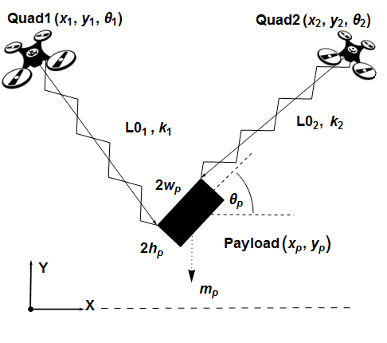

Figure - system setup

## model assumptions

Quadrotor:

1. Quad body and parts are **rigid**. *No* elasticity is included.
2. Geometry structure is **symmetrical** in relation to the principal axes. And the mass distribution is **uniform**. Hence the Inertia matrix is taken as pure diagonal.
3. **quads motion is treated as** **given**! Hence the quad pure dynamics and control are not considered here, and they are mentioned only to give a better perspective for the problem in hand.

Payload & cable construction:

1. The ‘cable’ which the payload is connected to, is modeled as a **lumped mass linear spring**, with initial length , and a linear returning force coefficient .
2. The cable is connected to the quadrotor exactly in its center of mass (C.G).

There is no friction and moment actuated through those hanging points.

1. In the payload hanging points there is an arbitrary **structural dumping** (resultant of hanging point friction and spring dumping).
2. The payload is a **rectangular box**, similar to a ‘CONEX’ cargo container, characterized by width of (, and height of (, and with inertia matrix .
3. There is no consideration in possible aerodynamic drag of the cables.
4. **Simplified aerodynamic forces** (lift and drag) on the payload are considered – will be addressed in the non-conservative forces section.

## Coordinate systems, and general coordinates

I – inertial coordinates frame. It is the global reference point for the problem.

Its’ axes are :

P – Payload coordinate frame. The origin is located at the C.G of that rigid body.

Since we are looking at 2D problem, for each system element we have 3D.O.F which are planar position and pitch angle. For the full 2D problem, we have the general coordinates as:

(1)

which is a 9 D.O.F problem.

The problem’s geometry

Schematics of the system, in accordance with the nomenclature listed above:

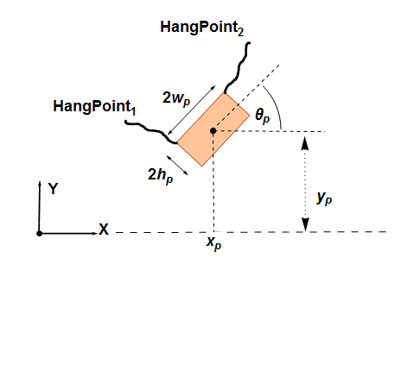

Figure - detailed sketch for hanging points geometry

Where

(2)

is the width of the payload. is the height of the payload.

## The Lagrangian of the system

By definition of the Lagrangian , we construct the system Lagrangian:

(3)

Where

The Lagrange equations will be calculated using the next equation (while using the common fact that V is not dependent on for mechanical systems):

(4)

– are the non-conservative forces.

*Note:* If I would consider the inner dynamics of each of the quads and their controllers – I would need to consider at least those 9 Equations Of Motion.

Because this is a ‘Research project’ and not a full research work - I will focus my desired analysis on the payload stability, and I will limit myself to deal with , while () are treated as given.

The dimensional 9 EOM are described in Appendix A for reference.

## non-conservative forces

we consider the next general forces (for the payload-related general coordinates):

- *structural dumping*

As described briefly in the assumptions section above. It is related to the relative movement of the payload to each of the quadrotors, and will be written as:

; (5)

- *aerodynamic forces*

While the desire is to use simple terms for the aerodynamic contribution, I will assume just drag forces in x,y directions. Furthermore, I’ll assume which is like ones’ of ‘CONEX’ cargo container.

(6)

u,v are the air velocities in the relevant directions.

## Equations of Motion (dimensional)

As mentioned above, from now on we deal with only 3D.O.F – for the general coordinates of the payload.

From (4), using (3),(5),(6), and rearranging, we can get the *dimensional* equations of motion for the payload:

(7)

Where:

(8)

* *note*: ‘c’ is for Cos(), ‘s’ is for Sin()

## Non-dimensional Equations of Motion

Scaling the dimensional variables according to these relations:

; (9)

This results also in:

;

So **the non-dimensional equations** can be written in matrix form in the following way:

**(10)**

Where ( :

; ;

;

;

; ; ;

## further analysis assumptions

in order to simplify the analysis continuation and to focus on the method, I’ll assume the geometry of the system is symmetric. Hence: **, =1** from here next.

Moreover (around the payloads’ Z axis, in center of gravity) is the one relevant for a rectangular shape which is:

(11)

I’ll check only for the case where quadrotors inputs are:

(12)

Limiting case test of elastic pendulum is shown in Appendix 1.

# Equilibrium analysis

## Equilibrium points:

We find the equilibrium possible states by setting all time derivatives to zero ().

It results with all accelerations, aerodynamic forces, and dumping forces and moments are zeroed.

The solutions are:

**;**  (13)

* From now on I’ll relate only to because this is the case of the quads can take the payload. The 2nd case can be related to similar case of inverted pendulum.

## Linearizing about that equilibrium point

The goal now is to find the natural frequencies of the system. it is done by looking on the effect of small deviations around the equilibrium point, while the aerodynamic and dumping forces are zeroed. Using perturbations syntax:

; ; (14)

Detailed derivation of the equations is in *Appendix B*.

The linearized equation , in B7, lead to :

; ; (15)

Where

It can be verified that for , we always get , ,and >0 .

## Reducing order of the system dynamics to 2DOF

It can be shown (detailed in *Appendix C*) that, for certain parameters, we can get :

(16)

While is larger than we can neglect the dynamics of and relate only to the dynamics of general coordinates of x, y.

We return to the full non-dimensional equations of motion and set where .

Looking at the 3rd equation from (10):

(17)

and term for can be extracted.

further details are elaborated in *Appendix D*.

the resultant 2DOF equations (of ) are:

(18)

Where:

; ;

# Asymptotic analysis

*for selected limiting cases that reveal a Hopf bifurcation and/or an orbital instability

## Maneuvers

Planned maneuvers to test the system are:

1. hover
2. translation of payload from points A to B, in a straight line. With equal or different quads heights.

Trajectory can be described for example as:



(*)

# Numerical analysis

*for asymptotic validation vs general maneuver

# Discussion

TBD

# Summary

I described the 2D dynamics of system of 2 quadrotors and 1 connected rigid body payload.

I verified against limiting cases of:

1. elastic pendulum

Non-dimensional equations were submitted, and equilibrium analysis was done.

Soon I will do the asymptotic analysis in order to find the stability criteria for the system.

Numerical analysis is done and will be displayed to verify the theoretical findings.

# Acknowledgements

Thanks for my instructor professor Oded G. for his patience and the detailed guidance through this work.

# References

1. Aghdam, Abdulghafoor Salehzadeh et al. “Cooperative Load Transport with Movable Load Center of Mass Using Multiple Quadrotor UAVs.” 2016 4th International Conference on Control, Instrumentation, and Automation, ICCIA 2016. Institute of Electrical and Electronics Engineers Inc., 2016. 23–27.
2. Bouabdallah, S. “Design and Control of Quadrotors With Application To Autonomous Flying.” École Polytechnique Fédérale De Lausanne, À La Faculté Des Sciences Et Techniques De L’Ingénieur 3727.3727 (2007): 61.
3. Sadr, S. et al. “Dynamics Modeling and Control of a Quadrotor with Swing Load.” Journal of Robotics 2014.December (2014): 1–12. Journal of Robotics. Web.
4. Zhicheng H. Et Al , “A survey on the formation control of multiple quadrotors”, Ubiquitous Robots and Ambient Intelligence (URAI), 2017 14th International Conference on.
5. J. Enciu and J. F. Horn. "Flight Performance Optimization of a Multilift Rotorcraft Formation", Journal of Aircraft, Vol. 54, No. 4 (2017), pp. 1521-1538. <https://doi.org/10.2514/1.C034111>
6. Acevedo JJ, Arue BC, Maza I, and Ollero A, Cooperative large area surveillance with a team of aerial mobile robots for large endurance missions, J. Intell. Robotic Systems, 70, 329-345, 2013.
7. Aginsky Z. and Gottlieb, O., Nonlinear bifurcation structure of panels subject to periodic acoustic fluid-structure interaction, AIAA Journal, 50 (9), 1979-1992, 2012.
8. Agmon, N, Urieli D and Stone P, Multiagent patrol generalized to complex environmental conditions, Proc. 25th AAAI Conf. Artificial Intelligence, 1090-1095, 2011
9. Alexis K, Nikolakopoulos G, Tzes A, [Switching model predictive attitude control for a quadrotor helicopter subject to atmospheric disturbances](http://www.sciencedirect.com/science/article/pii/S0967066111001262), Control Eng. Practice, 19, 1195–1207, 2011.
10. Bernard M, Kondak K, Maza I and Ollero A, Autonomous transportation and deployment with aerial robots for search and rescue missions, J. Field Robotics, 28, 914-931, 2011.
11. Das S, Halder U, and Maity D, Chaotic dynamics in social foraging of swarms – an analysis, IEEE Trans. Systems, Man, and Cybernetics B, 42, 1288-1293, 2012.
12. Ebeling W, and Schimansky-Geier L, Swarm dynamics, attractors and bifurcations of active Brownian motion, Eur. Phys. J., Special Topics, 157, 17-31, 2008.
13. Elor Y. and Bruckstein F, Uniform multi-agent deployment in a ring, Theoretical Computer Sci. 412, 783-795, 2011.
14. Escareno J, Salazar S, Romero H, and Lozano R, Trajectory control of a quadrotor subject to 2D wind disturbances, J. Intelligent Robotic Systems, 70, 51-63, 2013.
15. Garnier S, Combe M, Jost, C and Theraulaz G, Do ants need to estimate the geometrical properties of trail bifurcations to find an efficient route? A swarm robotics test bet, PLoS Comp. Biology, 9, e1002903, 1-12, 2013.
16. Gottlieb, O. and Habib G, Nonlinear model-based estimation of quadratic and cubic damping mechanisms that govern the dynamics of a chaotic spherical pendulum, J. Vibration and Control, 18, 4, 536-547, 2012.
17. Gutschmidt S. and Gottlieb O, Nonlinear dynamic behavior of a microbeam array subject to parametric actuation at low medium and large DC-voltages, Nonlinear Dynamics, 67, 1-36, 2012.
18. Hoffmann GM, Huang H, Waslander SL, and Tomlin CJ, [Precision flight control for a multi-vehicle quadrotor helicopter test bed](http://www.sciencedirect.com/science/article/pii/S0967066111000712)", Control Engineering Practice, 19, 1023–1036, 2011.
19. Kendoul F, David L, Fantoni I, and Lozano R, [Real-time nonlinear embedded control for an autonomous quadrotor helicopter](http://arc.aiaa.org/doi/pdf/10.2514/1.27882), AIAA J. Guidance Control Dynamics, 30, 1049-1061, 2007
20. Kevorkian J, and Cole JD, Multiple Scale and Singular Perturbation Methods, Springer, 1995.
21. Kumar V and Michael N, Opportunities and challenges with autonomous micro aerial vehicles, Int. J. Robotics Res. 31, 1279-1291, 2012.
22. Leishman JG, Principles of Helicopter Aerodynamics, 2nd ed., Cambridge University Press, 2006.
23. Liu YF, and Passino KM, Cohesive behaviors of multiagent systems with information flow constraints, IEEE Trans. Automatic Control, 51, 1734-1748, 2006.
24. Mazal L, and Gurfil P, Cluster flight algorithms for disaggregated satellites, J. Guidance Control and Dynamics, 36, 124-135, 2013.
25. Mellinger D, Michael N, and Kumar V, [Trajectory generation and control for precise aggressive maneuvers with quadrotors](http://ijr.sagepub.com/content/31/5/664), J. Robotics Research, 31, 664-67, 2012.
26. Mier-y-Teran-Romero L, Forgoston E, and Schwartz I, Coherent pattern prediction in swarms
27. of delay-coupled agents, IEEE Trnas. Robotics, 28, 1034-1044, 2012.
28. Nabet B,·Leonard NE, Couzin ID, Levin SA, Dynamics of Decision Making in Animal Group Motion, J Nonlinear Science, 19, 399–435, 2009.
29. Nayfeh AH and Balachandran B, Applied Nonlinear Dynamics, Wiley, 1996.
30. [Nijmeijer](http://www.amazon.com/Henk-Nijmeijer/e/B0034NHBUW/ref=ntt_athr_dp_pel_1) H, [and van der Schaft](http://www.amazon.com/s/ref=ntt_athr_dp_sr_2?_encoding=UTF8&field-author=Arjan%20van%20der%20Schaft&search-alias=books&sort=relevancerank) A, Nonlinear Dynamical Control Systems, Springer, 2010.
31. Oung R and D’Andrea, The distributed flight array, Mechatorincs, 21, 908-917, 2011.
32. Raffo GV, Ortega GM, and Rubio FR, [An integral predictive/nonlinear H∞ control structure for quadrotor helicopter](http://www.sciencedirect.com/science/article/pii/S0005109809004798), Automatica, 46, 29–39, 2010.
33. Ribak G, Rand D, Weihs D, and Ayali A, Role of wing pronation in evasive steering of locusts, J Comp Physiol, A 198, 541–555, 2012.
34. Schoellig AP, Mueller FL, D’Andrea R, Optimization-based iterative learning for precise quadrocopter trajectory tracking, Autonomous Robot., 33, 103-127, 2012.
35. Shklash A, Ariel G, Shneiderman E., and Ben-Jacob E, Smart swarms of bacteria inspired agents with performance adaptable interactions, PLoS Comput. Biol 7, e1002177, 1-11, 2011.
36. Sreenath K and Kumar V, Dynamics, control and planning for cooperative manipulation of payloads suspended by cables from multiple quadrotor robots, Proc. Robotics Science and Systems Conf., 1-8, Berlin, Germany June 24-28, 2013.
37. Sreenath K. Michael N, and Kumar V, Trajectory generation and control of a quadrotor with a cable-suspended load, a differentially-flat hybrid system, Proc. IEEE Int. Conf. Robotics and Automation, 4873-4880, Karlsruhe, Germany, May, 2013.
38. Young GF, Scardovi L, Cavagna A, Giardina , and Leonard NE, Starling flock networks mange uncertainty in consensus at low cost, PLOS Computational Biology, 9, e1002894, 2013.
39. <https://www.mendeley.com/library/>

# Appendices

## Appendix 1 –Limiting case dynamics – elastic pendulum

Reminding about the full problem equations of motion, from (10):

When looking on elastic pendulum for lumped mass, we can assume:

1. for the lumped mass (hence doesn’t matter any more)
2. for the connection, only to the first base, and not the 2nd one (
3. Arbitrarily I will assume which means also the 1st base is static

The equations of motion become:

(1.1)

(1.2)

Finding the equilibrium point - we set the derivatives of to 0 :

(1.3)

The 1st option is the relevant one, for the considered state of .

We can also note that if considering : , which fits to a problem of a simple pendulum, hanged on a rod and not a spring.

assumption is yp>0 fits to , so otherwise it means the spring is to small and weak.

assumption is yp<0 fits to

### Linearization around the equilibrium point

**1st order linearization** is :

*Near equilibrium*:

Testing for the 1st equilibrium point of:

;

(1.4)

The equations are written as:

* Using (1.4) and neglecting small terms such as :

(1.5)

* Using the relation from equilibrium above to eliminate o(1) terms

(1.6)

It is equivalent to the matrix notation :

(1.7)

Where :

; ; ;

Where we know to find the natural frequencies by the requirement of:

(1.8)

It is an equation of 4th order for , the relevant solutions are:

(1.9)

, where **expecting**

If reformatting the above to it is equivalent to the natural frequency of simple pendulum with a constant length of !

*Extra Limiting cases:*

When it affects we get and which is similar to

## Appendix A –Equations of Motion for 9D.O.F case

From (4), using (3), we get the *dimensional* equations of motion for the 2 quads and the payload:

* no non-conservative forces are included here.

Where:

## Appendix B –Linearization, and natural frequencies

In this section, I’ll linearize the equations of motion, and find the natural frequencies of the free non forced system.

Reminding the non-dimensional equations from (10):

We set

; ; (B1)

; ;

While

; ; (B2)

I’ll manipulate the equations before further calculation:

Defining :

(B3)

And eliminating for this analysis, getting:

(B4)

Later on I’ll use small angles rounding:

(B5)

and neglecting multiplications of the small perturbations elements (i.e. , , etc.).

Remember that quads locations are also given, as in (12).

I would like to develop the terms by a Taylor series expansion.

(B6)

after small angle assumption is:

After implementing (B6) in (B4), and eliminating more small elements multiplications:

(B7)

Or setting in the matrix form of which gives:

; (B8)

Where the natural frequencies are calculated from:

(B9)

For the y component we get uncoupled frequency as:

(B10)

For components we get coupled frequencies as :

; (B11)

Where

Conditions for >0 :

, (B12)

For , it is straight forward that also .

gives which is also always true.

## Appendix C –system parameters vs. natural frequencies

As continuation to Appendix B natural frequencies – I’ll show here the change of and their relations as functions of the parameters .

The assumed characteristic values range of those variables are:

;

If referring to from (B11) we see it should be a big number in order to get >>1.

behavior can be seen by:

   

It is expected that for for , without any seen dependency on , we’ll get high ratio between the frequencies.

Verifying for the relation itself we note few working areas:

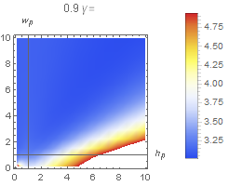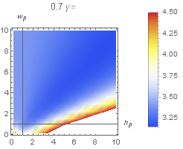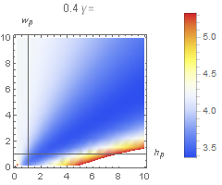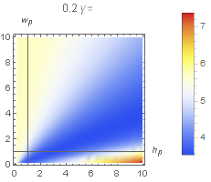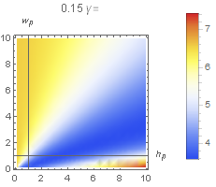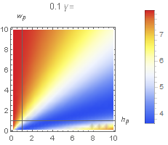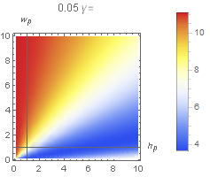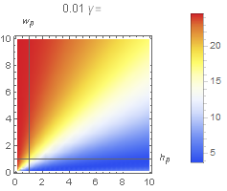

It is noted that for small we get high values of .

Numeric examples :

|  |  |  |  |  |  |
| --- | --- | --- | --- | --- | --- |
|  |  |  |  |  |  |
| **0.01** | **10** | **2** |  |  |  |
| 0.25 | 10 | 2 |  |  |  |
| 0.01 | 2 | 2 |  |  |  |
| 0.05 | 2 | 2 | 1.764 | 0.218 | 8.08 |

For given it is noted that affects, almost, only on .

For given , is not high enough to neglect as part of the system degrees of freedom.

## Appendix D – reducing system’s DOF

For the case of , I would like to neglect by setting , where .

Back to the starting 3DOF EOM (10) I will isolate using the 3rd equation, in order to get and use it back in 1st two equations of x,y. and by that getting 2DOF dynamics to investigate asymptotically.

*The procedure is:*

From 3rd equation of (10):

, where

we write it as:

**(D1)**

In order to extract we **use first order approximation**:

(D2)

to get:

; (D3)

And **use Taylor series** (around ) for A,B :

; (D4)

Where :

Setting (4,5) into (2) **and eliminating 2nd and 3rd order elements of ,** getting the relation :

*Next step is :*

Using (3) for the 1st two equations of (1) and getting new equations for a 2D.O.F problem, to asymptotically investigate :

**Non-dimensional 2D.O.F Equations of motion are:**

(D6)

Where:

; ;